Expiring Loan Report for Contractors
This procedure shows contractors how to run a report showing how they can see when loans are expiring in VelocityGO.

- Click on reports on the upper bar.
- Select all reports on the left-hand side.
- In the search bar near the upper right corner, search for “expiring loans”
- Select expiring loans under report name. This will take you to the report which will show you all loans expiring over the next 60 days.
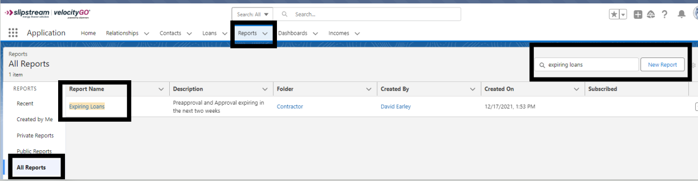

A few things to note:
This report is automatically set to include all loans expiring over the next 60 days. If you would like to view a larger or smaller range, select the funnel, then select the approval expiration date and the pre-approval expiration date and adjust the number of days. Select apply.

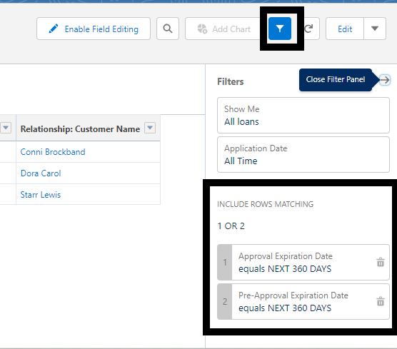

You also have the ability to export this report into excel by selecting the drop down and choosing export.

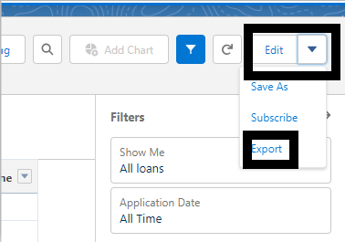

If you need to ask for an extension on a loan, please send an email to extensions@slipstreaminc.org at least 30 days prior to the loan expiration date and include the reason you are asking for an extension and when the project is fully complete along with all necessary documentation.

